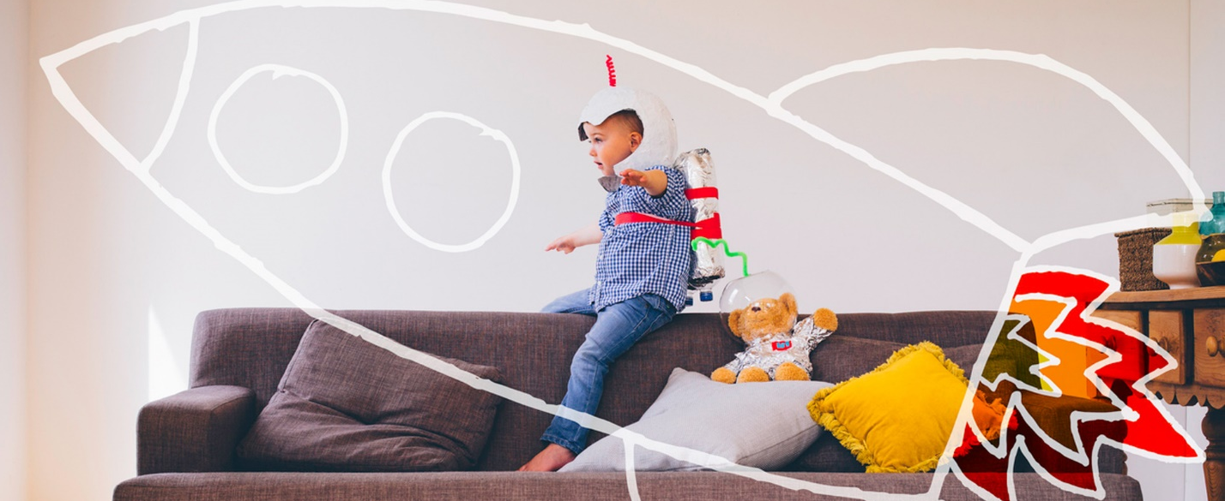
SPRING 2022
What Children Learn Through Play

Outdoor Play
- Observation skills are developed
- Exploration and development of senses
- Family cohesiveness developed through shared memories
- Physical benefits; fresh air, gross motor development
- Opportunities to draw conclusions from observations

Lap-time Reading
- Emotional and social connections happen with lap-time
- Imagination is fostered
- Vocabulary developed
- Literacy skills; rhyming, sounds, words can be written down, directionality introduced
- Knowledge base is enriched through fiction and non-fiction

Make Believe Play
- Language Development
- Cognitive Development
- Social and Emotional Development
- Fine Motor and Self-help Development
- Gross Motor Skills Development

Art
- Fine Motor Skills are developed
- Language and Literacy Development: Vocabulary expands, opportunities for verbal expression
- Social and Emotional Development
- Development of self-regulation and self-control

Music
- Fine Motor Skills are developed
- Improves mathematical learning and memory
- Exposure to language, new vocabulary and patterns
- Use of dynamics; soft, loud
- Social and Emotional Development
- Experience in movement

Exploration & Sensory Play
- Sense of observation is developed
- Cause and effect are explored
- Vocabulary is developed

Play is a child’s work. Their play and learning are intertwined.
Connect With Us
- Online — Starting Strong, High School and Beyond, Special Needs
- MomPossible community — mompossible.org
- Facebook — facebook.com/hslda.EduConsultants
- Email — info@hslda.org
- Phone — 540-338-5600

