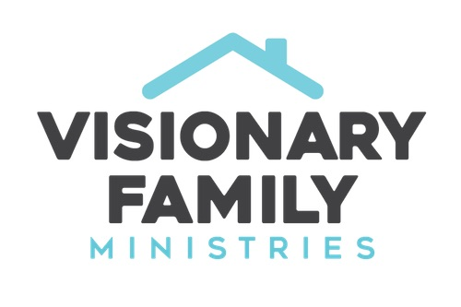
Your Family and God's Plan for the World
Dr. Rob Rienow

I. Family and the Gospel

II. A power-walk through the Scriptures

A. The first commandment – Genesis 1:28

B. The Earth was filled with evil – Genesis 6:5

C. Why God Chose Abraham – Genesis 18:18-19

D. The first commandment for human relationships – Ex. 20:12

E. The Great Commandment – Deut. 6:5-7

F. The final words of the Old Testament – Malachi 4:4-6

G. The first words of the New Testament – Luke 1:16

H. Jesus and the little children – Mark 10:13-16

I. The Great Commission echoes the First Commandment – Matt 28:18-20

J. The NT Church launches with generational vision – Acts 2:38-39

M. No greater joy… - 3 John 1:4

III. Conclusion and prayer

