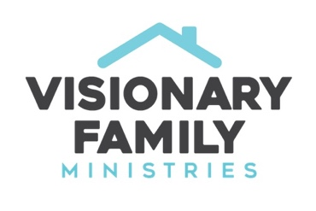
HEALING FAMILY RELATIONSHIPS
Dr. Rob Rienow

I. Every family struggles with sin and conflict

II. Roots of bitterness - Hebrews 12:15

A. Bitterness grows

B. How many times do I need to forgive? Matthew 18:21-22

III. Healing through prayer

A. Pray for your own heart.

B. The log and the speck - Matthew 7:3-5

IV. Healing through boundaries - Romans 12:18

A. Joseph and his brothers

B. Sweeping things under the rug is not healing

V. Healing through compassion - Matthew 9:36

A. The compassion of Jesus, Matthew 9:36

B. Pray for a heart of compassion

VI. The reconciliation line

